PROJECT

DESIGN

**OUTLINE**

### PREPARED FOR

**IAS Project : IIIT-Hyderabad**

### PREPARED BY

**TEAM - Two**

**[Vatsal Soni - 2018201005]**

**[Darshan Kansagara - 2018201033]**

**[Dhawal Jain - 2018201065]**

# 1. Introduction to the Project

**Definition:** Service component is microservice based architecture of platform that coordinate with all other subsystem and different services. It includes user authentication, model packaging, deployment, and its relevant monitoring logging. It provide runtime for model deployment and invoke user’s action and notification. It will also manages scheduling of model on gateway or server with different scheduling policy.

**Scope**: Our platform provides a set of independent services that the app developer can use for app development with his own custom code updations. The platform provides various independent services like Security service (Authentication and Authorization), Build and Deployment capabilities , Logging and monitoring, Notification and Actions Service, Auto Scaling, Prediction and inference of AI model, Resource management, Scheduling service and repository to store data.

# 2. Test Cases

## 2.1 Test cases- [used to test the team’s module]

**Authentication and Authorisation :**

1. **Check Username and password**
   1. Input : username and password
   2. Output: Success or failure
   3. Description : It will verify username and password from DB and return result.
2. **Check User access permission**
   1. Input : Username
   2. Output : User’s token along with list of services accessible to user
   3. Description : It check user access permission from repository and return list of services accessible to user.

**Deployment Service**

1. **Check model is deployed/ Check Model endpoint**
   1. Input : Given Model API endpoint
   2. Output : Got response if model is deployed and running

or URL not found if model is not deployed

* 1. Description : It will check whether model is deployed or not by accessing its end-point. If API is accessible we got response. But if model is not up and running we got 404 page not found error.

**Scheduling Service :**

1. **Check model is up between start and end time**
   1. Input : Start time , Endtime, Model API endpoint.
   2. Output : Check Model is schedule and running up between start and end time.
   3. Description :It will check whether model is up and running between given time. It will ping model in after every time interval.

**Wrapping Service:**

1. **Check weather model data is packaged properly.**
   1. Input: Model information,
   2. Output: Package model
   3. Description: It will check model information in registry and then get the model data and config file from repository. It will create script file and package these files in one zip.
2. **Check weather package is received by AI run machine.**
   1. Input: Packaged data (Zip file)
   2. Output: Send it to AI run machine
   3. Description: It will send Packaged file to AI run machine where actual model will run.

**Notification & Action Service :**

1. **Check Action performed or not** 
   1. Input : Model API endpoint action code
   2. Output : Check console that action performed and output seen on console or not and notification receive to user registered email/mobile or not.
   3. Description : It will check whether user’s action code is executed or not after Model had correctly predicted output.
2. **Check Notification receive or not** 
   1. Input : Model API endpoint and prediction output.
   2. Output : Whether user receive notification on register mobile or email or not.
   3. Description : After model got result and it should notify user about it. Checking whether user receive any notification about it or not.

**Logging and Monitoring**

1. **Check log file Content is updated or not**
   1. Input: Log file path , ServiceName, Logmsg
   2. Output : Log File content change or not
   3. Description : Check whether logmsg given by service is written on log file or not.

## 2.2 Overall project test cases (relevant to the module)

1. **Check New Deployment services instance created or not when high Load** 
   1. Input : User Model with High CPU load on deployment service
   2. Output : new deployment service should run and up
   3. Description : When High load in CPU load balancer of Server should create new instance of Deployment service and it should running and up to handle other request.
2. **Check Model is schedule and running on gateway or not** 
   1. Input : Model with start and endtime , Gateway socket
   2. Output : Model must schedule and running up on given gateway.
   3. Description : Given user model should schedule and running up on given gateway and must given endpoint of it.
3. **Check User should receive response or not**
   1. Input : Notification and response of request Id
   2. Output : User should gets response
   3. Description : When central server receive response from notification service it should be redirect to user and provide response of it.

# 3. Solution design considerations

## 3.1 Design big picture

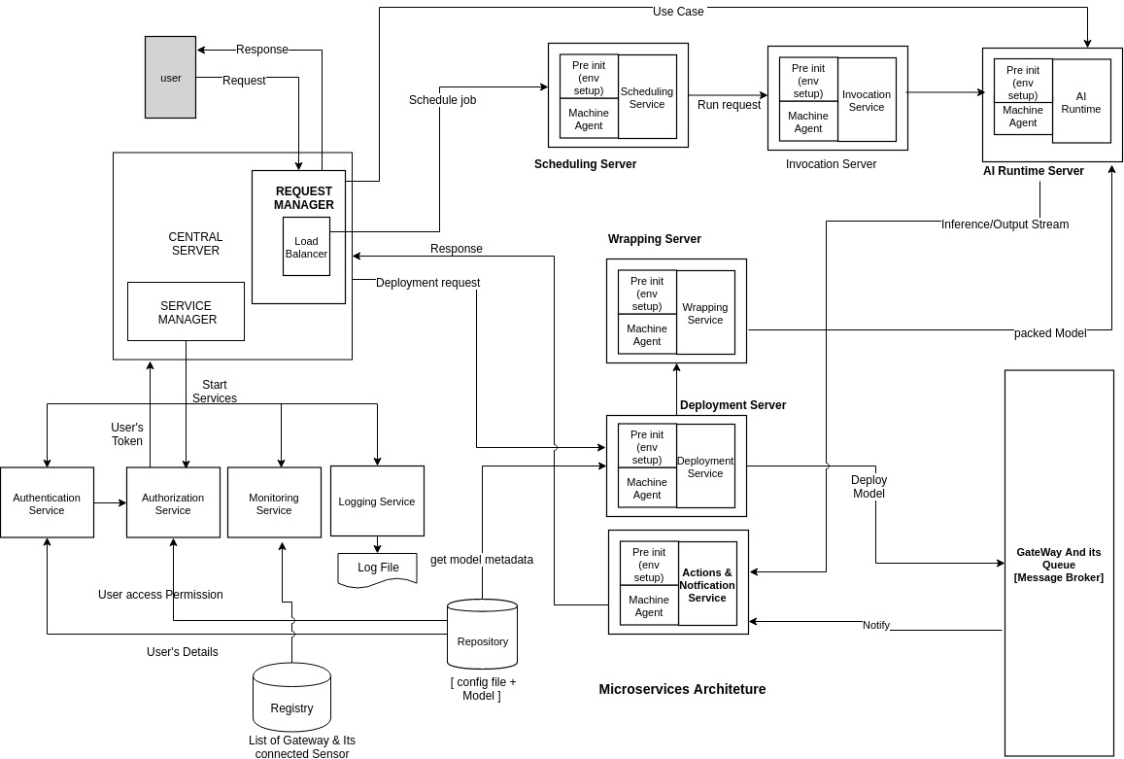

# 

## 3.2 Environment to be used

* 64-bit OS (Linux)
* Minimum RAM requirement : 4GB
* Processor : intel pentium i3
* Dockerised image used for model transfer.
* SSH support to OS for transferring files and models.

## 3.3 Technologies to be used

* Microservice Based Architecture - Python Flask based
* Tensorflow serving runtime
* Docker
* Scheduler lib of python
* Bash Shell scripts can be used to make installation/configuration automated for deployment of model.
* Elastic search, kibana for centralized logging and monitoring

## 3.4 OVERALL SYSTEM FLOW AND INTERACTION

* As Service Manager starts common services such as authentication, Logging and monitoring will starts and running up.
* When User request comes, Machine agent of central server will create new instance of microservice and Load balancer will distribute load among them.
* Deployment Service takes model as input and config file and pass it to wrapper service.
* Wrapper service will package model along with action, model and script file into zip and passed it to scheduler.
* When User will give config file in which start and end time of deployment of model is mentioned and based on that scheduler will invoke service to deploy model.
* AI run time provide support to deploy and run model to do inferencing.
* Finally AI model do inferencing and match given use case provided by user and send notification to the Notification service.
* Notification and action service will perform user’s action and return back response to the user.

## 3.5 Approach for communication & connectivity

* We used Rest API endpoint for inter-service communication.
* RabbitMQ used for queueing and interaction between various component.
* We used client-server model for communication between various services.
* We used RPC for intercommunication between server.

## 3.6 Registry & repository

* **Registry**
  + It will contain the stats of every service (what instances are running on what machines, binary files location of each service in the common file system etc.)
  + It contains list of gateway and and its connected sensors( sensor id, geolocation, Type ).
* **Repository:**
  + It will contain one directory per user which will in-turn contain one directory per service and will contain all the version-revisions of that service.
  + It also contains config file and saved model.

## **3.**7S**ervice lifecycle Manager**

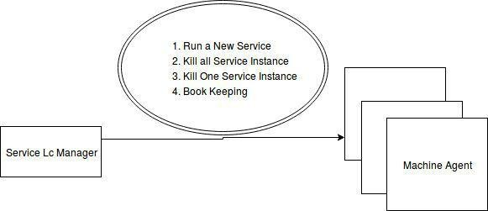

**Main functionalities of this module are as follows :**

1. **Run a Service instance:** Gather stats from monitoring module and based on the stats, start a service in a docker container on that machine.
2. **Kill all Service instances running on single machine input:(ipaddress, hostname)**

Get info about services running on that machine from registry. Then kill those service containers.

**3. Kill a single Service instance input:(ipaddress, hostname, serviceid**

Kill that service instance from docker container using input.

## 3.8 Interactions between modules

* Service life cycle is responsible for invoking services. Each service is itself a micro service which runs on different-different server instances. Through rest api one service will interact with another service. Also AI model transfer will be done by network file system. Through ssh, invocation service service run AI model on AI run machine. Run model service will interact with input stream device through RabbitMQ.

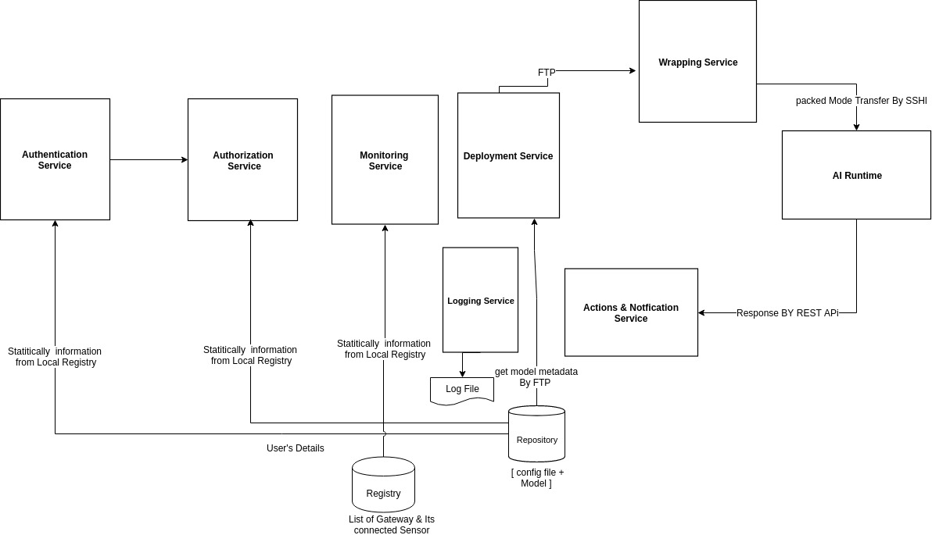

## 3.9 Wire and file formats

1. REST/GRPC to communicate between TF Serving APIs and server
2. AMQP to communicate between IoT Sub system and Server / AI system
3. REST APIs carrying JSON data to communicate between client and server
4. Each message sent to a MQ will have an authentication token in the msg header. Message body will contain the svc name, function name and its parameters along with their data types. We will also have an identifier(correlation id) for every message and will be included as key of that message in the MQ.

**File formats:**

Multiple files with different file formats will be used.

1. Bash scripts - sh format
2. Python files - py format
3. Metadata - json format

# 4. User’s view of system

**4.1 Web Service :**

* Any kind of user will have access to platform and its services through a flask web app.
* It can upload a model through it and create a config file corresponding to that and has a facility to upload it along with the corresponding models.
* End user can also see the status of all running models on its dashboard and the status of all the gateway on the same web page.

**4.2 Setup :**

* User must have tensorflow support to its system so that it can build a application that our platform support.
* All the secure shell communication must be properly running on user system.
* Rabbit MQ is to be installed on a dedicated machine which should act as the MQ broker. The ip and port of the machine where this broker listens to must be saved to be used by all other machines in the network.
* Database like MySQL must be installed along with an user. The endpoint to where and how to access the database must be defined/stored in a configuration file.

**4.3 Configure :**

Configuration of the platform according to dependencies setup in the above phase must be done here.

* Configuration of how to connect with Rabbit MQ.
* Configuration of how Data service will connect to the DB.
* Configure browser with proper version so as to support flask application
* Configuration of machines which will be used for running a heavy AI model.

# 5. Key Data structures

**Below are the list of data structures we have used in the application development :**

* Python Library Data Structures :List, Dictionary, Set.
* Special Data Structure:
  + HashMap For model and its location storage and its fast retrieval.
  + Queue:For message passing.
  + JSON: For storing config file in json format.
* **APIs**
  + Authentication Service:
    - /user_authenticate
  + Deployment Service
    - /deployService
  + Scheduling Service
    - /ScheduleService
  + Invocation Service
    - /invocationService/start
  + Notification & Action Service
    - /notification
  + Logging Service
    - /loggingService
  + Monitoring Service
    - /monitoring/model_status
    - /monitoring/gateway_status
  + Inferencing Service
    - /inferenceSerivce
  + Authorization Service
    - /authorizationService

# 6. Interactions & Interfaces

* The first interaction of the both the user(one uploading model and other giving use case) with the system is with web service(we have used flask) with the help of which it can send its request for model deploy or can send a use case for the model that are already deployed.
* User can also see all the deployed and to be deployed Models in the list on the dashboard or say UI interface.
* All the file transfer is done using secure shell.
* An html page where user shall be able to submit a Machine Learning Model for the deployment. User shall be able to give the details like, On premises or On Cloud deployed type, type of AI/IoT it has to deal with, input and output format/type etc.

# 7. Persistence

* We maintain persistent log file for continuous event triggering.
* We used python pickle library for storage and tensorflow model saver for saving model into repository.
* In case one microservice is down ,even than rest of the system will remain entact.
* In case system crashes, these services brings back the system in the last state with the help of logging.

Low Level Design

# 1. Lifecycle of the Service module

# 

# 

# 2. List the sub modules

2.1 Logging

2.2 Monitoring

2.3 Deployment

2.4 Notifications and Actions

2.5 Security

# 3. Brief overview of each sub module

### 3.1 Logging service

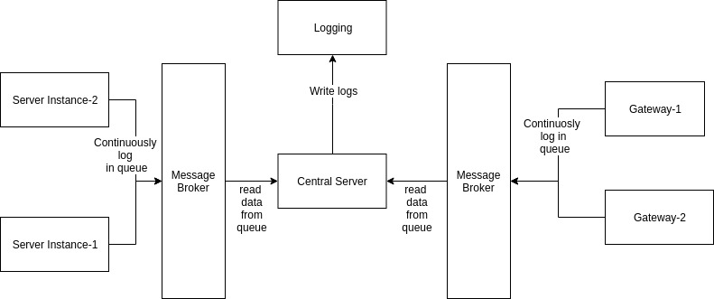

**Main functionalities of logging are as follows:**

* Logging all the activities to manage resources.
* To find root cause of crash of our application platform by writing error and debugging logs.
* Search and download log.
* It will access the log file and pinpoint the last event that was triggered and take appropriate action.

### 3.2 Monitoring service

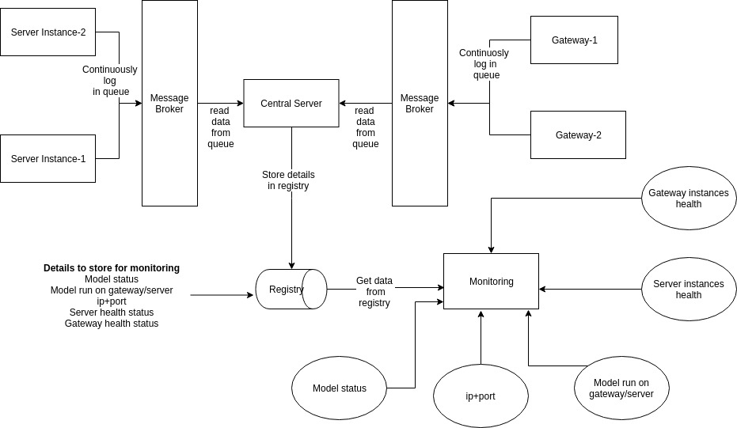

**Main functionalities of monitoring are as follows:**

* It monitors the health of all the server instances and gateways.
* It helps in load balancing task because it keeps track of all the server instances.
* It continuously updates the registry to store dynamic information which helps topological manager.

### 3.3 Deployment service

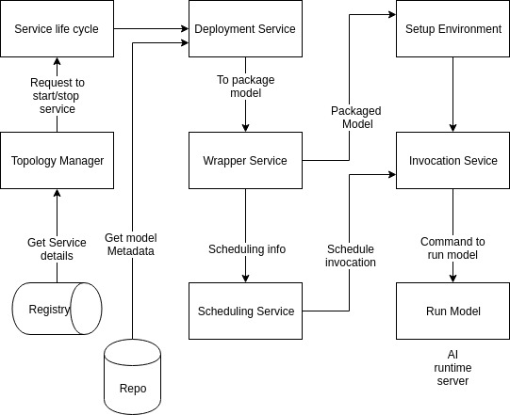

**Main functionalities of deployment services are as follows:**

* It helps in deploying AI models in gateways and server instances.
* Inferencing can be done using deployment service only.
* Deployment service is responsible for scheduling of AI models.
* It is responsible for setting up runtime environment in server instances/gateways.

### 3.4 Security (Authentication, Authorization and Encryption)

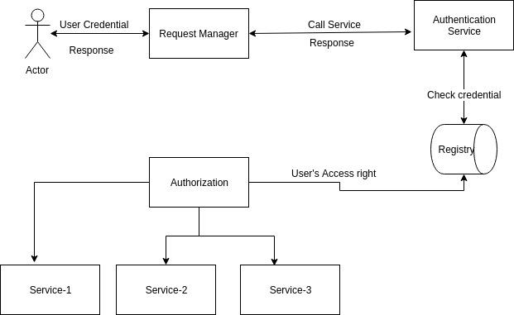

**Main functionalities of Authentication and Authorization are as follows:**

* This service takes care of authentication of user and the service it is authorized to use.
* For maintaining data security and preventing system from external attacker it is used.
* It also maintains the integrity of data.
* Data is transferred in encrypted manner to prevent middleman attack.

### 3.5 Notification & Actions

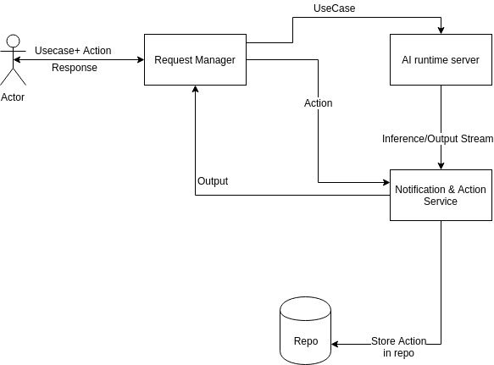

**Main functionalities of Notification & Actions are as follows:**

* It notify user about specific event.
* Notification service send response along with status code to users.
* It gives alert or notify user when response of user’s request is ready.
* Action service is responsible for taking appropriate action which user has specified as input.

# 4. Interactions between other modules

